**Tutorial 2 (Comparison of protein migration profiles (ACR11 and Fd-GOGAT (Glu1)) by heat map using a multiple protein search function)**

To compare protein migration profiles among proteins of interest, you can use a “multiple protein search” function. First, you need to select a sample (in this tutorial, stroma).

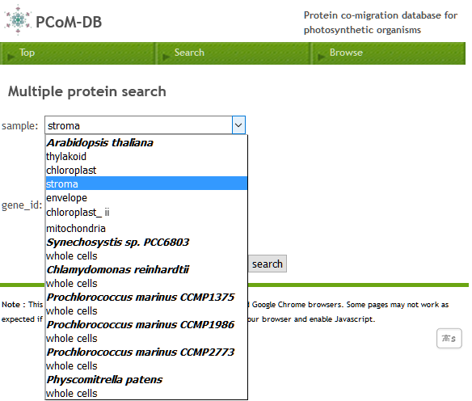

Then, you can input gene IDs (AT5G04140(for Glu1) and AT1G16880 (for ACR11)).

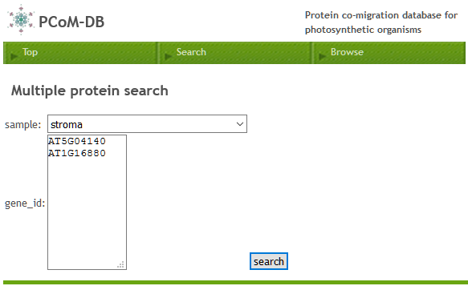

After clicking search button, the resulting page will show you the heat maps of the migration profiles for your search proteins.

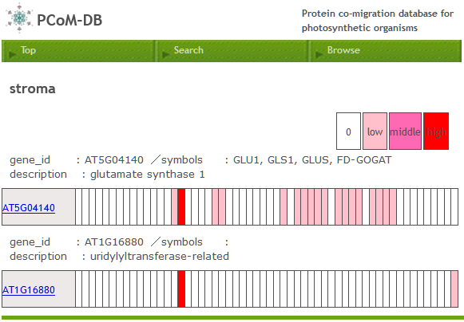

Each column represents a gel slice of a BN-PAGE gel and gel slices are ordered left (a top of gel) to right (a bottom of gel). A red-colored column indicates that your search protein is identified in the corresponding gel slice. The depth of the red-color reflects the relative abundance of the protein accumulation level, which was estimated by a label-free semi-quantitative method, emPAI (Exponentially Modified Protein Abundance Index).

The 19th columns of both Glu1 (AT5G04140) and ACR11 (AT1G16880) are strong red-colored, suggesting that Glu1 and ACR11 forms a protein complex in the corresponding gel slice.

You can click the GeneID (AT5G04140 or AT1G16880) to see the protein migration profile in “Browse” mode.